Sprint 1

|  |  |
| --- | --- |
| Team ID | PNT2022TMID43478 |
| Project Name | Personal Assistance for Seniors Who Are SelfReliant |

1. Launch IBM Watson IoT Platform to create the virtual devices :

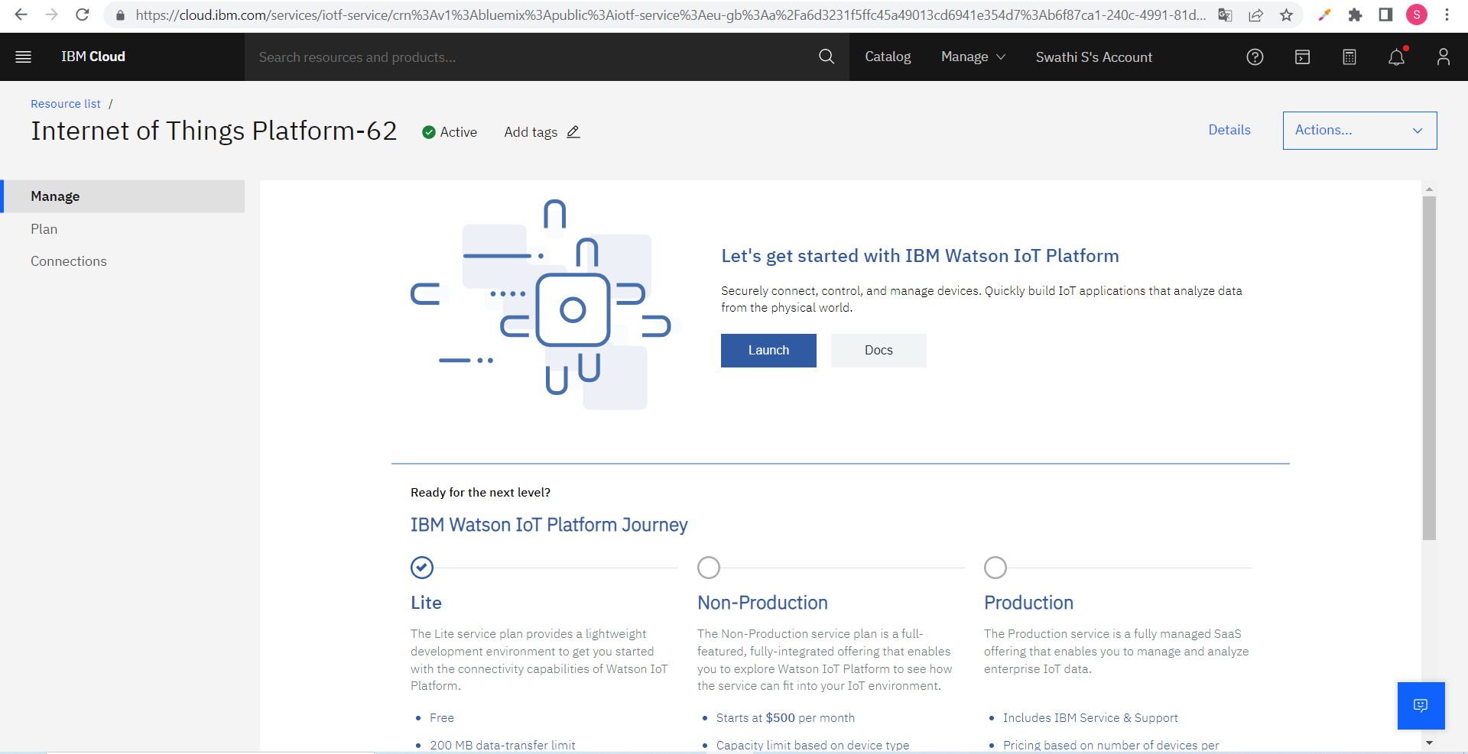

1. Create the Virtual Device :

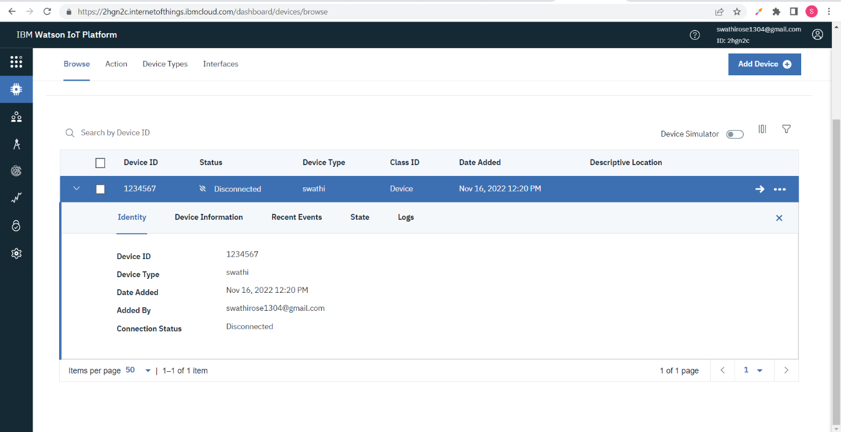

1. Install Node-red Services to develop a Web Application :

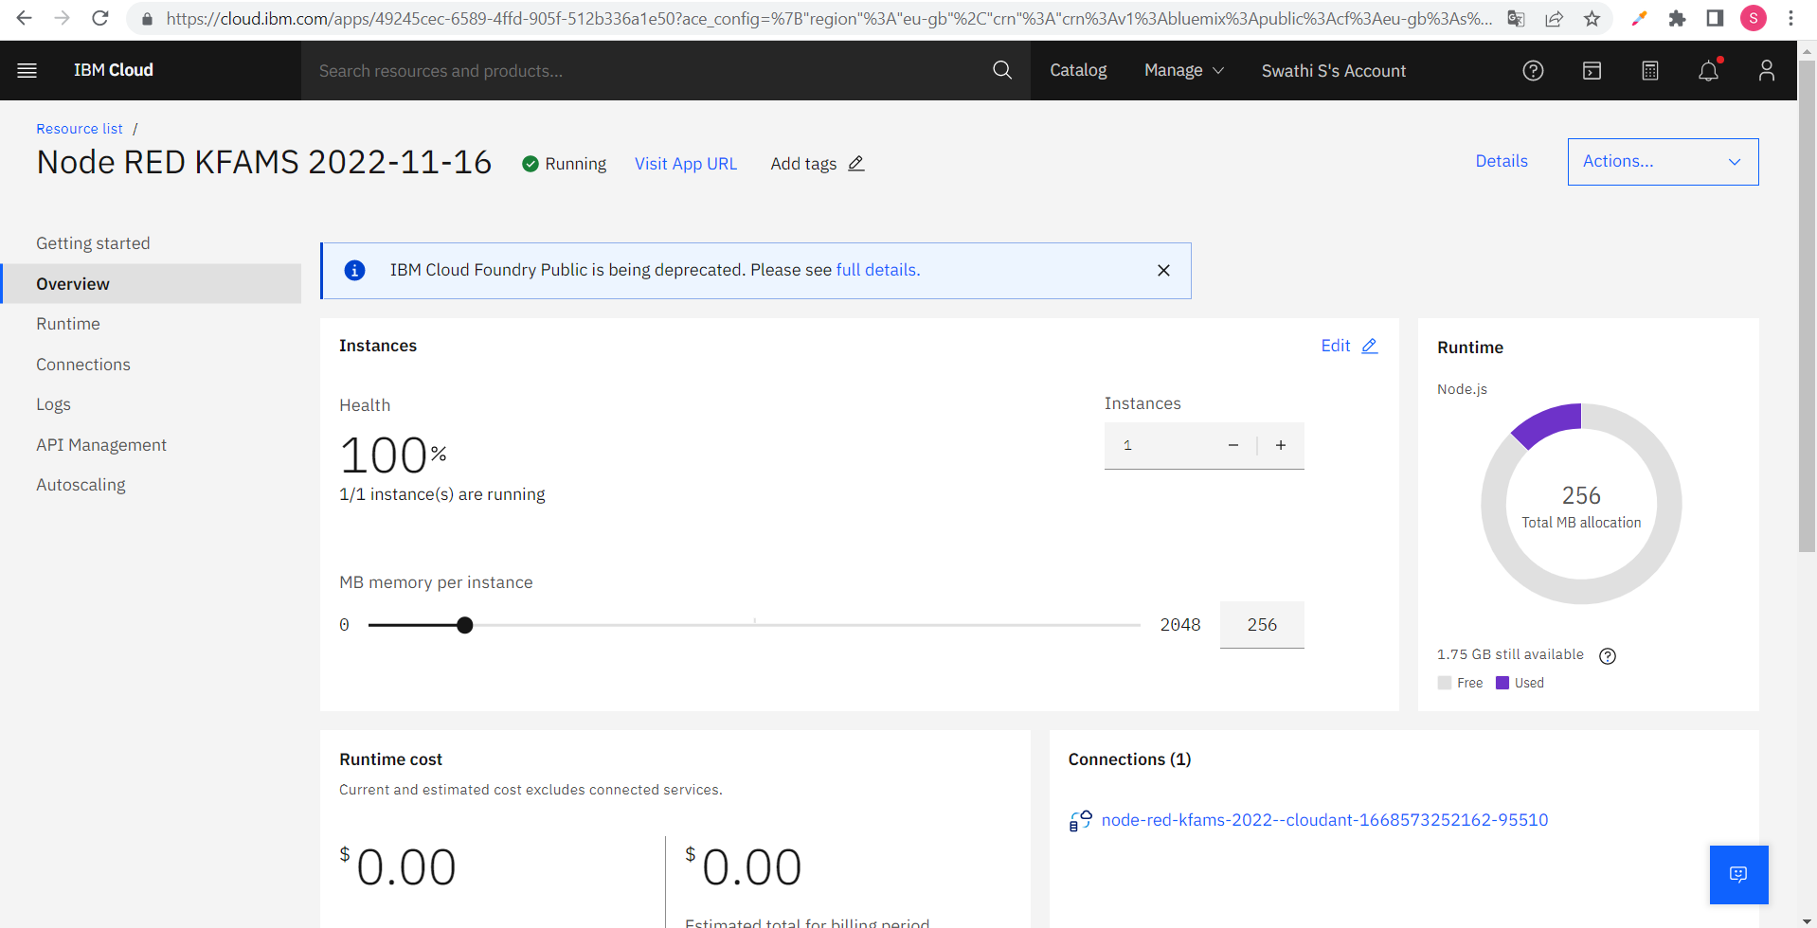

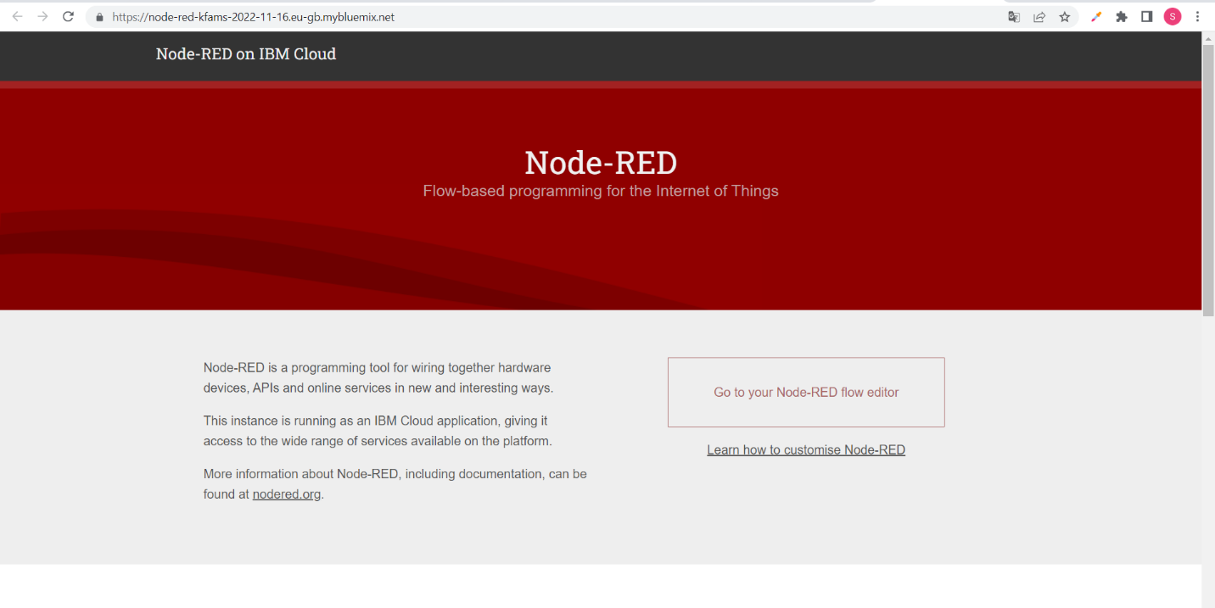

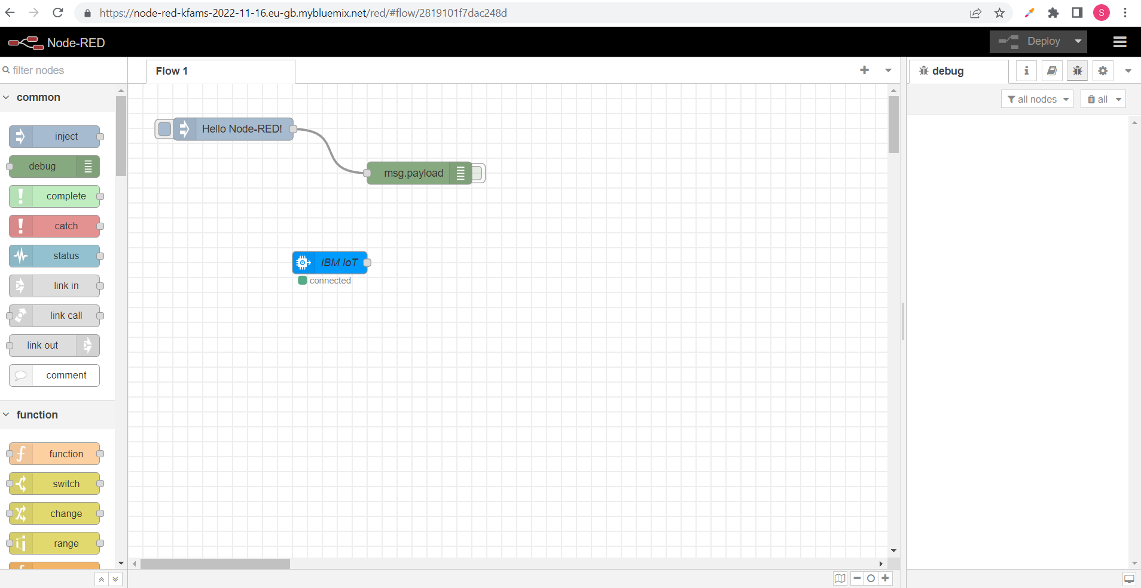

1. Install Cloudant DB to Store the Medicine Datas :

